To successfully complete the required KP Learn web-based learning courses, follow the instructions below the list.
Type the entire title as listed as there may be similar courses available then cross reference with the class ID provided.
Note: Class ID numbers subject to change.

All Students and Faculty complete 1-5
  - Ethic and Compliance Introduction: Building a Culture of Trust 2019 (CONDITION OF EMPLOYMENT) (00804725) 20 minutes
  - Interacting with People with Disabilities (00704694) 30 minutes
  - Prevention of Workplace Violence (00736908) 60 minutes
  - Safety Training: CA and HI- Hospital/MOB - INITIAL/Comprehensive - OSHA Safety/EOC/Waste 2019 (00804319) 45 minutes
  - 2019-2020 Preventing Harassment in the Workplace for Employees (00814601) 60 minutes
Stop here unless you are a Diagnostic Imaging Student

Diagnostic Imaging Students (RT, NM, US) only- continue with 6-15
  - Abuse Assessment and Reporting-SCAL for 2019 (00804590) 60 minutes
  - Active Shooter aka Imminent Danger (00716242) 30 minutes
  - Bloodborne Pathogens Awareness Training 2019 (00804622) 20 minutes
  - 2019 KP Phishing Prevention Training (00808497) 30 minutes
  - Medical Imaging Compliance (00731833) 60 minutes
  - MRI Safety Training - Level 1 (00816416) 30 minutes
  - Radiation Safety and Patient Care 2019 (00804301) 15 minutes
  - Safe Patient Handling (Hospital INITIAL ASSIGNMENT CA ONLY) 2019 (00804643) 30 minutes
  - Signs and Symptoms of Stroke (00738345) 10 minutes
  - Using Language Assistance Services in California (00791574) 45 minutes

Computer/Software Requirements: To successfully complete courses on KP Learn, you must have the following computer and software requirements. If you don't have these, you may not be able to successfully start courses and any you complete may not be accurately recorded in KP Learn.
- PC computer (no Macintosh, tablets, or mobile devices)
- Chrome
- Disable/Turn-Off All Pop-Up Blockers

- Launch the browser.

- Type kplearn.kp.org in the address bar and click enter.
- Click Log into KP Learn. | 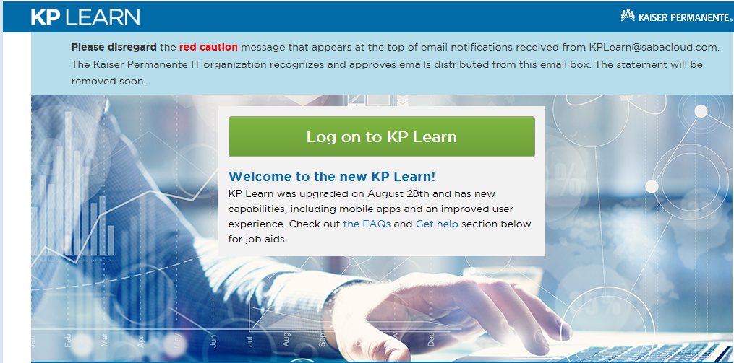
- Sign in using your NUID & Password (desktop credentials) provided by your Academic Liaison/Designee  When prompted to change your password: minimum of 8 characters, use at least one upper case, one lower case, and one number or special character  Note: Please retain your password for future use with other KP computer applications  For log in assistance contact the IT Service Desk 1-888-457-4872 | 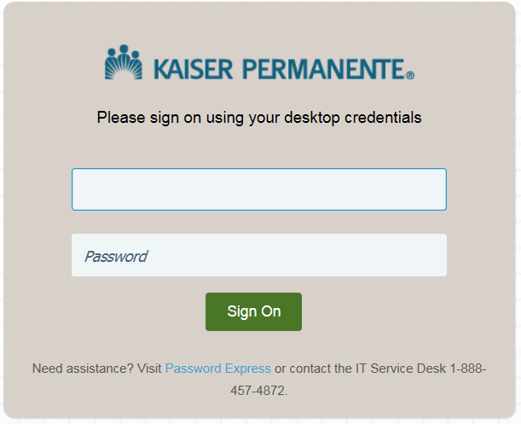
- Click Browse the Catalog | 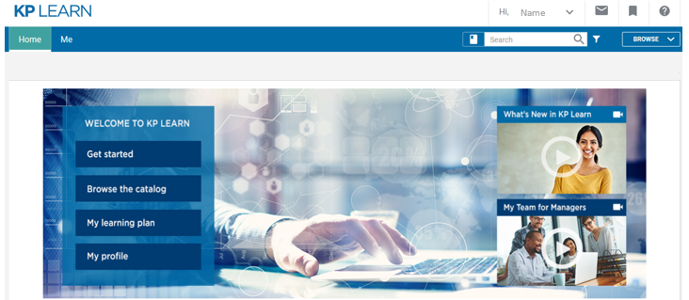
- Enter the Keyword, Class ID or Description in the Search field  Required courses are listed at the beginning of this document.  - Click the Search icon | 
- Verify course name provided by the Academic Liaison/Designee  and click on the title  Type the entire title as listed as there may be similar courses available then cross reference with the class ID provided.  Note: Class ID numbers subject to change.  Note: If you don’t finish the course in one sitting, go back to My Enrollments to re-launch the course. | 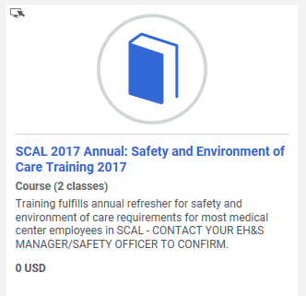  SAMPLE
- Verify correct course then click LAUNCH | 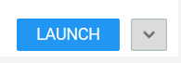
- Once you’re finished with the required courses, click the Me tab  Click Completed Learning | 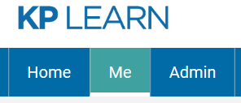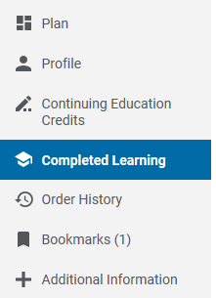
- Click on the Printer icon (in the upper right corner) and print My Completed Learning summary page of your completed learning courses  DO NOT click Print Certificate for each course | Click the Printer Icon  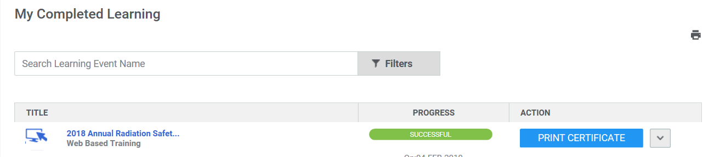  First Name  Last Name  First Name  Last Name
- Submit the My Completed Learning summary page with your Single PDF Prerequisite Packet to your Academic Liaison/Designee (individual course certificates are not required) | 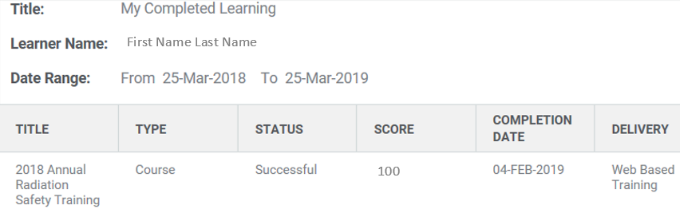
- Sign out

